1.
DOWNLOADING SOFTWARE
for Client

1 | Software – for the Client’s PC (or Windows 8 tablet):  Welcome to the Zenalyser Treatment System – a unique way of providing effective treatment together with daily monitoring and support. We really hope that you benefit from this development and would be delighted to hear your comments and suggestions. Simply write to ZenaMed Ltd and let us know what you think. Your views matter.  Before you can get started you will need to put the Zenalyser software on to your Windows 7 or later device. Just follow the steps below and you should have no trouble.  Insert data pen into a USB port. Open the data pen. Take the following steps:  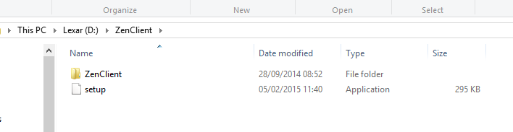  You may now receive a message: “Do you want to allow the following programme from an unknown publisher to make changes to your computer?” Click “Yes”  Double click on “setup”  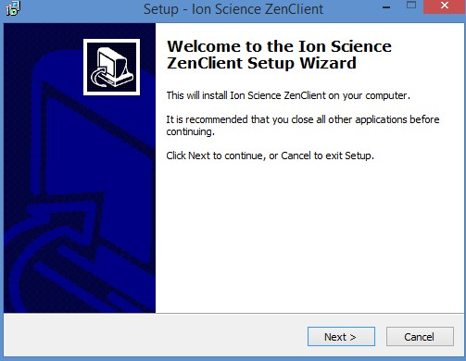  Click “Next”  Now complete the remaining steps – see below
2 | 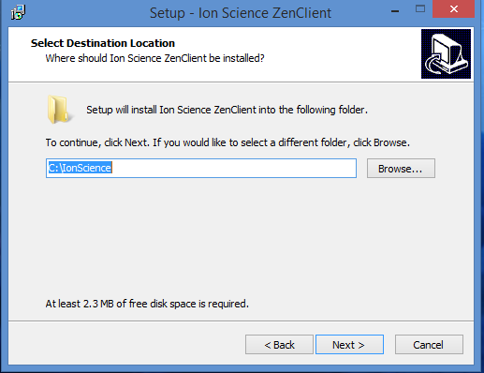  Click “Next”  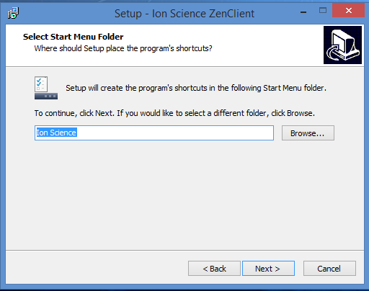  Click “Next”  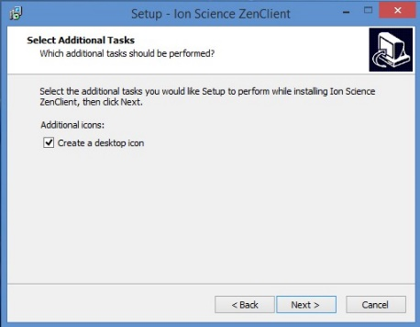  Click “Next”  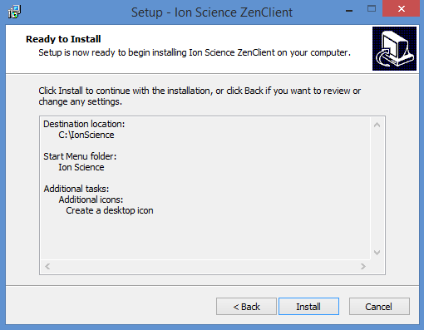  Click “Install”
3 | 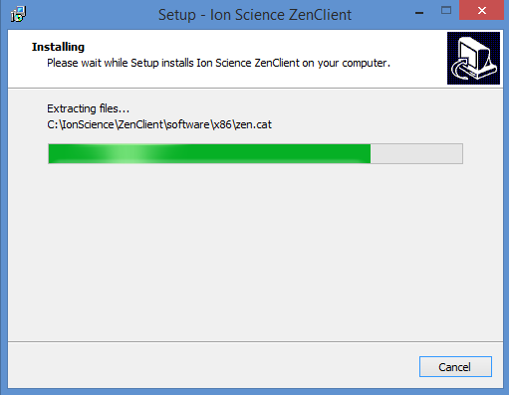  software installing  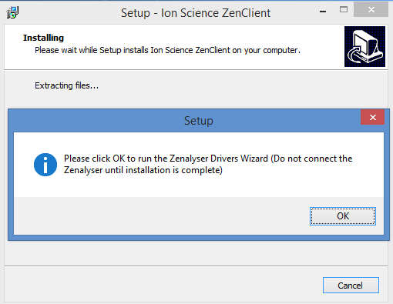  Click “OK”  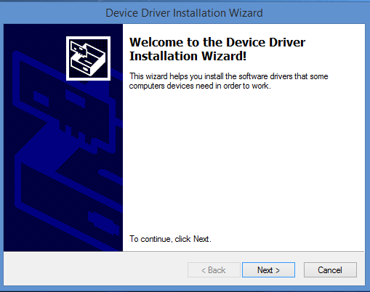  Click “Next”  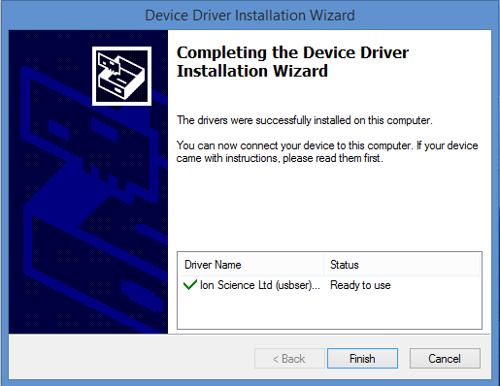  Click “Finish”

4 | 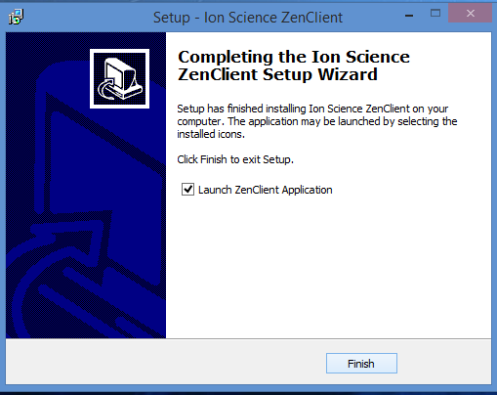  Click “Finish”  The Zenalyser® Client interface will open at the end of the setup process, and an icon will have been placed on your computer desktop  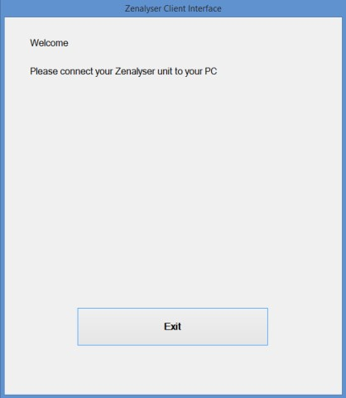  You have completed the ZenClient setup process. You are ready to take a breath sample and send the data to your Supporter  The Zenalyser® is simple to use. It requires just two presses of the Power button:  - The first press switches the Zenalsyer® on  - The second press starts the collection of the breath sample  - The Zenalyser® will switch itself off automatically  For the full Zenalyser® Operating Instructions see below
2.  Zenalyser® operating instructions  f0r client |  | Sound | Top  light
Attach a fresh mouth piece |  | - | -
Press Power button for 1/2 second, wait 10 seconds for warm up |  | purr
Zenalyser® ready for breath sample |  | steady bleep | flashing
Start blowing and press Power button again for ½ second |  | beep gets faster | steady
Blow for 10 seconds, the Zenalyser® will switch off automatically |  | fast beep – stop | success
When you have finished blowing, the lights will tell you if the sample was successful (green), or if you need to repeat (blue) or if there is a fault (red) |  |  | repeat sample
fault,
contact ZenaMed

Other warning lights:

Solid Red
Battery too low for the instrument to start/operate.
(Remedy: Charge battery before use).

Alternating Red/White
Indicates the lamp has not illuminated. This should occur only a few seconds after the pump is turned on. It will not occur immediately after switch on.
(Remedy: Repeat turning instrument on/off a couple of times – the lamp might strike – else return instrument to service centre to change lamp).

Alternating Red/Blue
After 30s after switch on, with pump off, indicated contaminated air in the system.
(Remedy: Repeat turning instrument on/off a couple of times in clean air).

Alternating Red/Magenta
After 30s with pump on, indicates a probable sensor fault
(Remedy: Instrument should be returned to service centre for overhaul and checking).

For instructions on how to send Zenalyser® data to your Supporter, see below

3.
Sending the Zenalyser® results to the Supporter

On your computer desktop, double click on the ZenPatient icon

Connect the Zenalyser® to your computer with the USB cable supplied – your name will appear
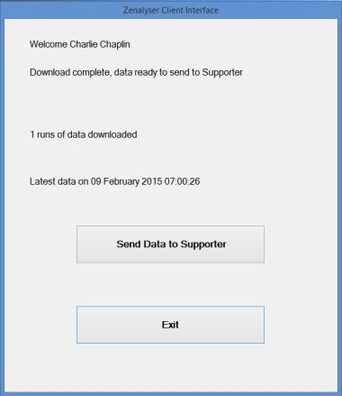
Click “Send Data to Supporter”

A message will appear when the data has been successfully sent
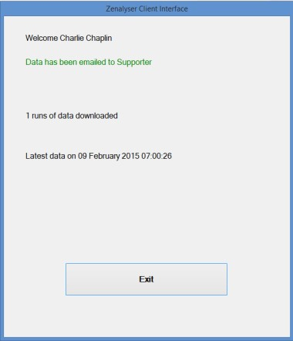
Click “Exit”

