New technology to support abstinence from alcohol, predict relapse and reduce out-patient costs
Dr Keron Fletcher, Royal College of Psychiatrists, Medical Director of ZenaMed Ltd

Introduction:
Supervised disulfiram with intensive support and monitoring has been shown to produce high abstinence rates in severely alcohol dependent patients over many years (Krampe, 2007), but is associated with inconvenience, high staff demands and high costs. Remote support and monitoring would make this long term intensive approach convenient, and reduce costs related to out-patient care. It would also be possible to assess when a patient stops disulfiram or starts to drink alcohol, thus predicting relapse before it becomes established.
Objectives:
To describe the specification, results and applications of an instrument (a Zenalyser®) that remotely monitors disulfiram compliance and breath alcohol levels.
Aims:
This poster describes a device (a Zenalyser®) which has value in the management of moderate to severe alcohol dependence.
Methods:
Alcohol and exhaled metabolites of disulfiram are both accurately detectable and quantifiable with different types of gas sensor. By combining these sensors in an instrument with appropriate software for simple data export and analysis, a breathalyser (Zenalyser^{®)} has been manufactured which enables remote support and monitoring. The system works like this:
- The patient who is prescribed disulfiram has a Zenalyser® at home or at work and blows into it each day.
- The patient exports the encrypted readings on a daily basis to the clinical team.
- The clinical team read the result and email the patient back with feedback and support.
Specifiations | Value
Weight (gms) | 260
Dimensions (cms) | 21 x 10 x 3
Disulfiram specificity & sensitivity: | specificity | sensitivity
200mgs daily  400mgs. 400mgs, 600mgs 3x/week | 100%  100% | 100%  84.5%
Sensor reactivity: | disulfiram | alcohol
Disulfiram sensor  Alcohol fuel cell | Yes  No | Yes  Yes

Results:
Fig. 1: data ranges for patients off or on disulfiram (no overlap)
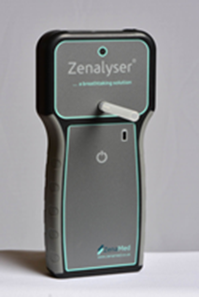
Fig. 2: Zenalyser®
0
200
400
600
800
1,000
No Disulfiram
Disulfiram
nmol
.

Example data

Green line = disulfiram metabolites, parts per million (ppm).
Red line = alcohol, μgm/100mls.
Orange line = therapeutic cut off .
(Therapeutic disulfiram level > 5ppm. No alcohol <5μmg/100mls).
Fig. 3: Disulfiram 200mgs daily, single 10 second breath sample:
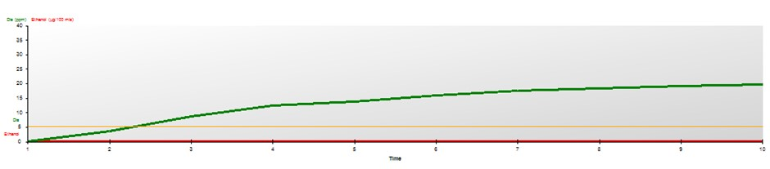
Fig. 4: Disulfiram 200mgs daily, cumulative samples over 20 days:
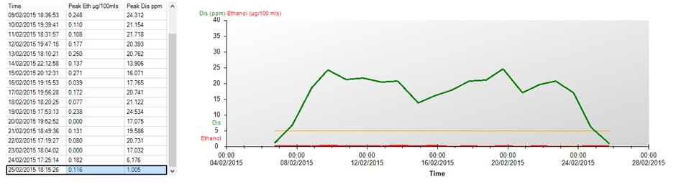
start end
Fig. 5: Alcohol (175mls, 13% wine), 30 minutes prior to sampling:
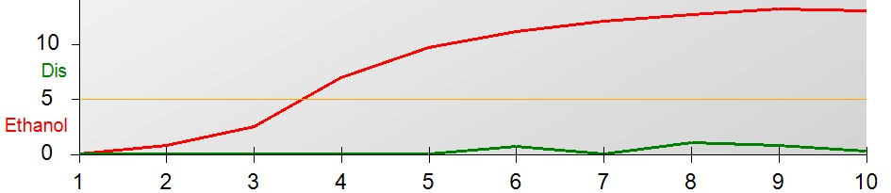
(
seconds
)
Cross reactivity is visible – alcohol activates the disulfiram sensor (green line). Sample collected over 10 seconds.

User experience and feedback
- Patient time required to take sample and export data = <1 minute.
- Clinic time required to import data and email patient with feedback and support = 2-4 minutes.

Predicting relapse
- Decreasing disulfiram metabolite levels.
- Appearance of alcohol.
- Patient stops sending data.

Applications
- Support and monitoring for patients who wish to abstain.
- Post detoxification support and monitoring.
- Family Drug and Alcohol Courts.
- Alcohol Treatment Orders.
- Occupational Health.
- Any high risk alcohol-related situation (e.g. violence, crime).
- Low cost alternative to residential rehabilitation.
Conclusions:
The Zenalyser® can remotely monitor disulfiram compliance and breath alcohol levels. It has a number of advantages that are of clinical value, not least of which is the potential to predict relapse before it becomes established, and to reduce costs associated with out-patient care.
References:
Krampe H, Stawicki S, Hoehe MR et al. (2007) Outpatient Longterm Intensive Therapy for Alcoholics (OLITA): a successful biopsychosocial approach to the treatment of alcoholism. Dialogues Clin Neurosci 9:399–412.

Copyright © 2015 Dr Keron Fletcher info@zenamed.co.uk www.zenamed.co.uk

