Very low cost intensive support and therapy for alcohol dependence using new technology

Dr Keron Fletcher, Royal College of Psychiatrists, Medical Director of Zenamed Ltd

Introduction:
Supervised disulfiram with intensive support and monitoring is the best form of treatment to maintain abstinence in moderate to severe alcohol dependence (Krampe et al, 2007; Kalra et al, 2014). However, both supervision of disulfiram and high intensity support have their limitations. Individuals are mobile, relationships breakdown and supervisors weary of their task. High intensity support places heavy demands on clinic staff, is inconvenient, leads to low rates of patient turn-over and carries high costs.
A new hand held breathalyser (a Zenalyser®) can remotely monitor disulfiram metabolites and alcohol on a breath sample and send encrypted data back to the clinical team. The clinical team can email feedback and support to the patient on a daily basis. This observational evaluation on a small sample of severely alcohol dependent patients sought to determine whether this system could work in clinical practise.
This poster describes the first clinical evaluation of the Zenalyser®.
Methods:
Ten patients with severe alcohol dependence were offered disulfiram support and monitoring with a Zenalyser®. Six patients used the device remotely, four attended the detoxification unit for regular breath sampling on a weekly or fortnightly basis. The period of Zenalyser® use ranged from 3 months to 3 years, with a mean follow up of 11.3 months.
The sample group consisted of the following:
- Two mothers whose children had been removed by the Courts.
- Two doctors under the supervision of their governing body, one of whom was suspended.
- Three soldiers due for discharge from the British Army because of alcohol dependence (follow up limited to 3 months each).
- Three patients from the locality who wished to have regular postdetox support.
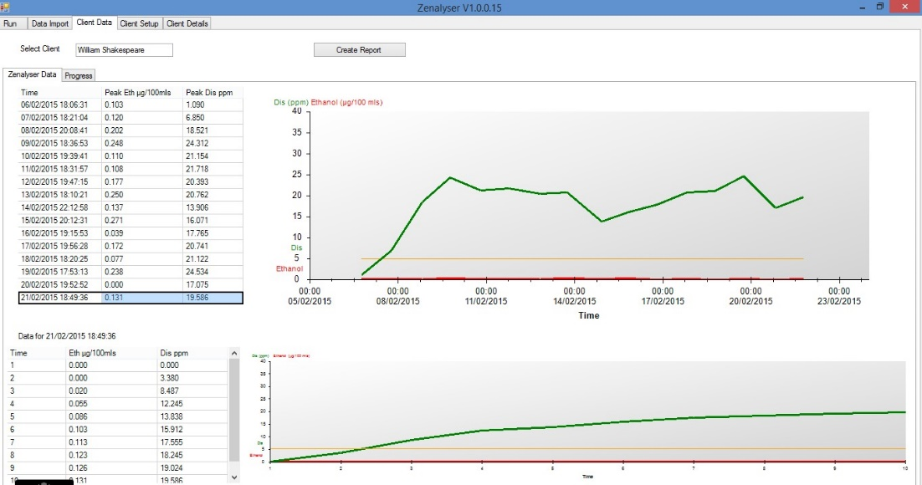

Fig. 1
Example of daily data sent from the Zenalyser® - upper table and graph is cumulative data, lower table and graph is data of a single selected day’s breath sample, second by second.

Results:

General outcomes
The Zenalyser® treatment system proved to be simple, quick, convenient and time saving. Remote Zenalyser® use had significant advantages over clinic Zenalyser® use (see “Other factors” below).

Patient outcomes
- Of the ten patient group, nine completely abstained from alcohol.
- One patient with a 30 year history of alcohol dependence and cirrhosis had two lapses of one week duration each. The patient used a remote Zenalyser® and stopped sending daily data, thus signalling difficulties and triggering rapid intervention on both occasions.
- Both mothers used Zenalyser® data in Court in support of treatment compliance and abstinence. They regained their children.
- Both doctors used Zenalyser® data in proceedings with their governing body. The doctor suspended for 3 years returned to medical practice.
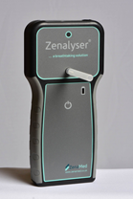

Other factors
The remote Zenalyser® system had several advantages over the clinic based Zenalyser®:
- The single patient who lapsed stopped sending data, thus signalling difficulties and triggering rapdie intervention. Both lapses lasted only a few days and did not become established. This could not have happened with intermittent use of the Zenalyser® in clinic.
- Components of good motivational support could be included in daily emails from the clinic to the patient whenever required e.g. information, advice, encouragement, feedback of progress
- Two patients who travelled to Australia and Germany could still be supported and monitored every day.
- Time demands on clinic staff were considerably reduced.
- Families were grateful for continuing daily post detoxification support from the clinic.

Conclusions:
The Zenalyser® can remotely monitor disulfiram compliance and breath alcohol levels, and enables support to be given on a daily basis. Remote Zenalyser® use is more convenient than clinic use, reduces out-patient time and associated costs, and leads to better relapse prediction than clinic Zenalyser® use. Costs are very low at 1.50€ per day (calculated over a 5 year period).
References:
Kalra G, De Sousa A, Shrivastava A: (2014) Disulfiram in the management of alcohol dependence. OJPsych 4:43-52
Krampe H, Stawicki S, Hoehe MR, et al: (2007) Outpatient Long-term Intensive Therapy for Alcoholics (OLITA): a successful biopsychosocial approach to the treatment of alcoholism. Dialogues Clin Neurosci. 9: 399–412.
Copyright © 2015 Dr Keron Fletcher info@zenamed.co.uk www.zenamed.co.uk

